**Khulna University of Engineering & Technology**



**ECE 3102: Industrial Electronics Laboratory**

**Subject:** **Design and Simulation** **of** **Light Dimming and Motor Speed Regulation System Using Power Semiconductor Devices**

**Submitted To: Submitted By:**

Md. Khorshed Alom Md.Shafe Ul Alam

Assistant Professor Roll: 2009035

Department of ECE Year: 3rd

KUET, Khulna, Bangladesh Semester: 1st

Naymur Rahman

Lecturer

Department of ECE

KUET, Khulna, Bangladesh

**Objectives:**

* To design and simulate a system for a small apartment that can turn electrical devices on and off and adjust their power levels as needed
* To observe how power electronics devices are used in everyday life

**Introduction:**

 Home automation systems are on the rise, offering unparalleled convenience and efficiency by allowing users to remotely control electrical devices or set programmed schedules. In our latest project, we've crafted a user-friendly home automation system tailored for a one-room apartment. By harnessing the power of semiconductor devices, our system achieves seamless switching and precise regulation of lights, a fan, and a water pump. Our design emphasizes simplicity and reliability, leveraging advanced semiconductor components to ensure dependable operation and efficient management of motor-based devices. Whether adjusting lighting levels, controlling fan speeds, or managing water flow, our system delivers precise control and enhanced convenience to users. By incorporating semiconductor technology into our system, we're not only enhancing its performance but also maximizing its durability and energy efficiency. This ensures that our home automation solution not only meets but exceeds the expectations of modern living standards.

**Theory:**

Our circuit design represents a skillful fusion of power semiconductor devices, meticulously selected for their specific functions in achieving meticulous control over various aspects of our home automation system. Let's explore the distinct functions of each component:

**SCR (Silicon Controlled Rectifier):** Serving as a unidirectional switch, the SCR regulates current flow in a singular direction. Its primary function is to control the speed of motors by adjusting the average voltage supplied to them. Through the manipulation of gate current via a variable resistor, we can finely adjust the motor's speed to suit specific needs and preferences.

**DIAC (Diode for Alternating Current):** The DIAC plays a crucial role as a bidirectional trigger diode in AC power control applications. It remains non-conductive until surpassing its breakover voltage, swiftly transitioning to a conductive state thereafter. This unique behavior enables it to initiate current flow in either direction, making it indispensable for triggering TRIACs in circuits such as light dimmers and motor speed controllers. The DIAC's precision in delivering stable triggering pulses ensures consistent and efficient operation in such scenarios.

**TRIAC (Triode for Alternating Current):** Functioning as a bidirectional AC switch, the TRIAC enables the regulation of light bulb intensity by modulating the portion of the AC sine wave supplied to the load. When paired with a DIAC, the TRIAC can initiate conduction at specific points in the AC cycle, allowing for precise control over light intensity and similar applications.

By leveraging the unique capabilities of these power semiconductor devices in our circuit design, we achieve unparalleled control and efficiency in managing lighting, motor speed, and other essential functions within our home automation system. This integration ensures seamless operation and enhances the overall convenience and energy efficiency of the system.

**Apparatus Required:**

Table 1: List of required apparatus

|  |  |  |  |
| --- | --- | --- | --- |
| SL No. | Apparatus Name | Rating | Quantity |
| 1 | DIAC | 50V, 1mA | 2 |
| 2 | TRIAC | IH=5mA, IT =1mA | 2 |
| 3 | Bulb | 220V, 100W | 2 |
| 4 | Fan/Motor | 220V, 50W, 2500RPM | 2 |
| 5 | Variable Resistor | 500kΩ, 100kΩ | 4 |
| 6 | Capacitor | 0.1 μF, 2 μF | 4 |
| 7 | SCR | IH=5mA, IT =1mA | 2 |
| 8 | Diode | 1N4007 | 2 |

**Circuit Diagram:**

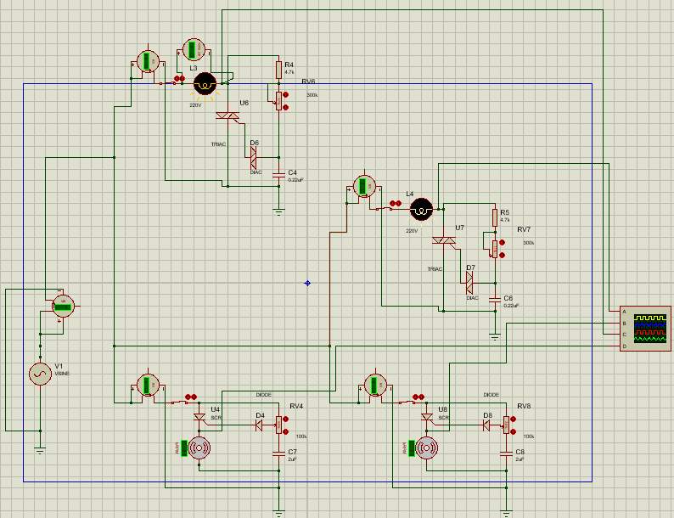

Fig 1: Simulation of electronic system for the switching and regulation of light, fan and motor

**Circuit Analysis:**

The circuit consists of three independent circuits:

* **Light Dimmer Circuit:** This setup utilizes TRIACs and DIACs to regulate the brightness of two light bulbs. The TRIAC acts like a variable valve for electricity flow to the bulbs, while the DIAC determines when the TRIAC opens and closes. By tweaking a knob, we adjust the timing of the TRIAC's opening, thus controlling the amount of electricity reaching the bulbs and adjusting their brightness.
* **Fan Speed Controller:** Here, we employ SCR components to govern the speed of an electric fan. The SCR manages the power supplied to the fan motor by deciding when to activate during the electrical cycle. Using a knob, we adjust the SCR's activation timing. This alteration in timing directly impacts the fan's speed, allowing us to regulate how fast it spins.
* **Water Pump Controller:** Similar to the fan speed controller, this system also utilizes an SCR to manage the speed of a water pump. By adjusting a knob, we determine when the SCR activates during the electrical cycle. When the SCR activates earlier, more power is delivered to the pump motor, increasing its speed. By tweaking the knob, we control the pump's speed by adjusting the SCR's activation timing.

**Result Analysis:**

We observed varying output waveforms corresponding to different values of the variable resistor. This variability allowed us to establish a range of resistance values that effectively regulated both the brightness of the light and the speed of the motor and fan. By adjusting the variable resistor within this range, we could finely tune the desired brightness for the light bulbs and achieve the desired speed for the motor and fan, offering flexible control tailored to specific preferences and requirements.

**For light dimmer circuit:**

**Waveform with 0Ω Resistor:**

* Resister range: 0kΩ – 150KΩ
* Output voltage: 219V-0.7V
* Output power range: 99.9 W-0.33 W

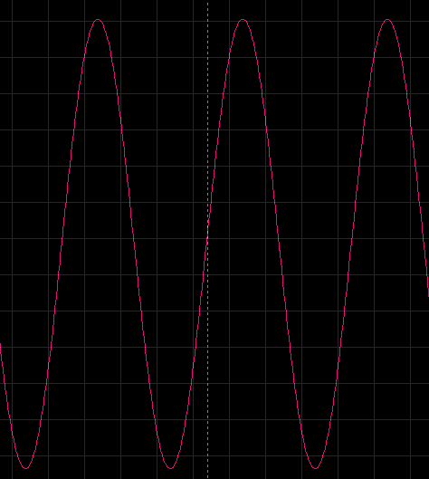

Fig 2: waveform when the value of the variable resistor is 0 ohm

In this setup, when the resistor is set to 0 ohms, it acts like a nearly direct path for the current in the diac triggering circuit. As a result, the diac fires very early in the positive AC cycle because there's little resistance to slow down the charging of the capacitor (C1). This means the triac stays conducting for a long time during the AC cycle. Because of this, the output waveform shows a complete sine wave, indicating that a lot of voltage reaches the bulbs, making them shine brightly.

**Waveform with 100Ω Resistor:**

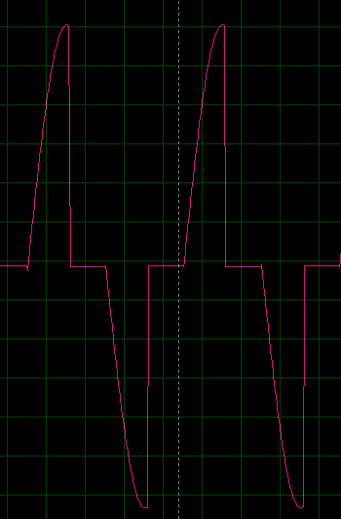

Fig 3: waveform when the value of the variable resistor is 100k ohm

Adding a 100 kΩ resistance slows down the current in the diac circuit, delaying the charging of capacitor C1 and the firing of the diac compared to having 0 ohms resistance. Consequently, the triac conducts for a slightly shorter duration. This results in a rectified sine wave output with a portion of the positive cycle truncated at the beginning, leading to a slightly lower average voltage reaching the bulbs and causing a dimmer light output compared to the scenario with 0 ohms resistance.

**Waveform with 150Ω Resistor:**

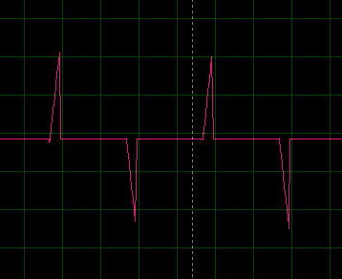

Fig 4: waveform when the value of the variable resistor is 150k ohm

Using a 150 kΩ resistor increases resistance in the diac circuit, delaying the firing point on the AC sine wave. This shorter firing time results in a significantly dimmer light output compared to before. Depending on the circuit and power supply, it might resemble a half-wave rectified sine wave if the delay is significant enough.

As the resistor value goes up from 0 ohm to 150 kΩ, the diac takes longer to fire on the positive AC sine wave because it takes more time for capacitor (C1) to charge. This means the triac conducts for less time, resulting in less power reaching the light bulbs and making them dimmer.

**For speed control circuit of motor:**

➢ Resister range: 0kΩ – 100KΩ

➢ Output power range: 0 W-51.3 W

➢ Speed range: 0-2.63 KRPM

**Waveform with 100Ω Resistor:**

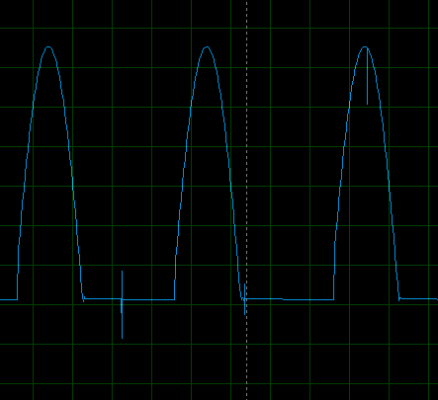

Fig 5: waveform when the value of the variable resistor is 100k ohm

The waveform displays a full cycle, suggesting the SCR triggers right away in the AC cycle.

With the larger resistor (100kΩ), more current flows through the SCR gate, triggering it instantly.

This leads to the SCR conducting for a longer time during the AC cycle, boosting the average power to the motor and speeding it up.

**Waveform with 30kΩ Resistor:**

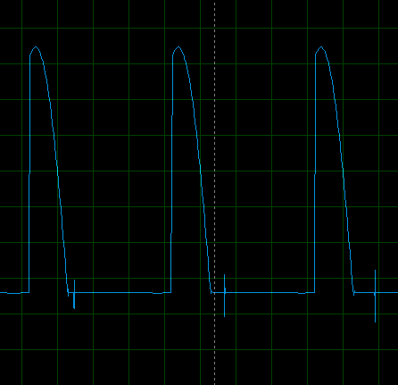

Fig 6: waveform when the value of the variable resistor is 30k ohm

This waveform might display a delayed conduction compared to the 100kΩ resistor.

Using a 30kΩ resistor slows down the current, causing it to reach the triggering voltage later in the AC cycle. As a result, the SCR conducts for a shorter time during the cycle, reducing the average power to the motor and slowing its speed.

**Waveform with a Different Resistor Value (e.g., 5kΩ or less):**

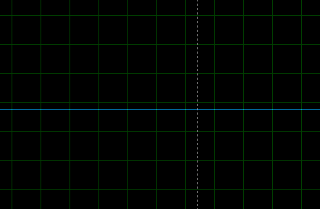

Fig 7: waveform when the value of the variable resistor is 10k ohm

When using a lower resistor value like 5kΩ, the waveform shows a flat line, indicating the motor is off. This happens because the low resistance allows all the current to pass through, preventing enough current from reaching the SCR gate to turn it on during the AC cycle.

By adjusting the variable resistor, we can control the average voltage sent to the motor, which directly affects its speed. The waveform analysis visually illustrates how this control mechanism operates.

**Discussion:**

The simulation results affirm the viability of employing power semiconductor devices in a fundamental home automation system. The light dimmer circuit adeptly adjusted the brightness of the light bulb by regulating the conduction time of the TRIAC through the variable resistor. Through waveform analysis, it was verified that a lower resistor value prompted an earlier firing point for the DIAC on the AC sine wave, prolonging TRIAC conduction and resulting in brighter light. Conversely, a higher resistor value delayed DIAC firing, shortening TRIAC conduction and yielding dimmer light. Similarly, the motor speed controller circuit utilizing the SCR operated as anticipated. Analysis of the output waveform highlighted the significance of the SCR's turn-on point within the AC cycle for motor speed modulation. While the current design offers rudimentary control, future iterations integrating microcontrollers, sensors, and communication interfaces could enrich the system with enhanced automation and user-friendly features. Such advancements hold the promise of delivering more seamless and intuitive control over home appliances, further enhancing the overall convenience and efficiency of the automation system.

**Conclusion:**

In short, this project created and tested a basic home automation system for a one-room apartment. It used special electronic devices called TRIACs and SCRs to control lights and motor speed. The system worked well, adjusting light brightness and motor speed as needed. We carefully studied the signals produced by the system, which helped us understand how everything worked together. This analysis showed that the design is reliable and accurate. By making it easy to control lights and motors, this project shows how home automation can make life more convenient and save energy at home.

**Reference:**

* https://steemit.com/science/@vinzie1/engineering-101-light-dimmer-using-a-triac-and-diac
* https://www.electricaleasy.com/2014/12/basics-of-power-electronics.html